QHP AMA MAP Hypertension Protocol Clinical Guideline

Hypertension Medication Treatment Protocol Summary
Adults without CHF, CAD, pregnancy, CKD stage 3, or albuminuria >300 mg/dL or >300 mg/g ACR

Patients NOT on Antihypertensive Medication
- Start dihydropyridine CCB + ACEI or ARB as single-pill combination (SPC). Examples: Amlodipine/Olmesartan (Azor), Amlodipine/Valsartan (Exforge), Amlodipine/Telmisartan (Twynsta), Trandolapril/Verapamil (Tarka).
- If risk of hypotension, frailty, or intolerance → use low-dose SPC or CCB monotherapy.
- If history of CCB intolerance (e.g., edema) → switch to thiazide-like diuretic (Indapamide, chlorthalidone, HCTZ—not preferred).
- If diabetes with albuminuria and monotherapy preferred → use ACEI or ARB.
- Reassess BP every 2–4 weeks; use SMBP (self-measured blood pressure) if available.
- If BP not at goal → proceed to “Patients ALREADY on Antihypertensive Medication.”

Patients ALREADY on Antihypertensive Medication
- If on SPC → increase dose or add thiazide-like/thiazide diuretic.
- If diabetic with albuminuria & monotherapy preferred → use ACEI or ARB.
- If on CCB monotherapy → add ACEI or ARB (preferably SPC).
- If on ACEI/ARB monotherapy → add CCB (preferably SPC).
- If on thiazide or thiazide-like diuretic monotherapy → add ACEI or ARB.
- Reassess BP every 2–4 weeks until goal reached; SMBP recommended.
- If still uncontrolled → consider spironolactone or specialty referral.

Listing of SPCs
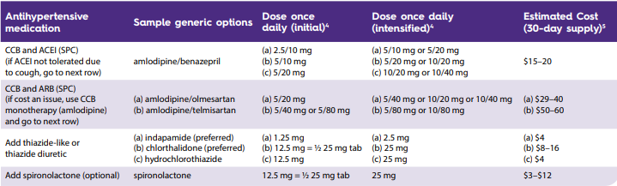
See full table: aafp.org → Hypertension Combination Products. aafp.org/pubs/afp/issues/2020/0315/p341/jcr:content/root/aafp-article-primary-content-container/aafp_article_main_par/aafp_tables_content3.enlarge.html

SMBP-Self Measured Blood Pressure Monitoring
Measures Blood pressure outside a medical facility - usually at home
Automated validated digital BP cuff upper arm cuff memory storage of 30 or more readings
Correct size bp cuff
Measure BPs twice each morning and evening
Before taking BP meds
Empty bladder before taking BPs
Avoid exercise, caffeine and tobacco for 30 minutes before taking morning BP
Find a quiet location
Sit upright in supportive chair with uncrossed legs with feet on floor
Rest measuring arm on a side table or furniture with upper arm at mid chest level
Face palm up
Place cuff so bottom of cuff is just above elbow
Rest quietly for 5 minutes before taking first BP measurement
No talking, TV, phone or electronics use
Write down bp and pulse rate
Wait 1 minute
Write down bp and pulse rate
Report these reading to provider staff as directed
Average the SMBP readings into Average Systolic and Average Diastolic pressures (minimum of 3 days)
SMBP goal is an average of 135/85 which is equivalent to 140/90 in the office
If average of SMBP is greater than 135/85, Diagnose HTN and initiate or intensify treatment and recheck in 4 weeks
If average SMBP is greater than 180/100, patient requires immediate evaluation and management by physician; patient likely to have hypertension
  - 7-step SMBP Quick Guide | AMA

Nursing/Clinical Staff Role: "Improving Blood Pressure Control with AMA MAP"
Educate patients on taking home blood pressures. Candidates include patients diagnosed with hypertension (HTN), those with elevated BPs without an HTN diagnosis, and those with labile or masked hypertension.
Help the patient select the correct cuff size.
Measure at midpoint of upper arm with cloth tape measure
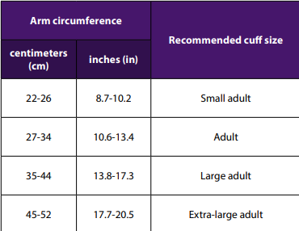
Automated BP machines are preferred over manual cuffs.
Help the patient select a validated BP machine.
https://www.validatebp.org
Train patients on how to take home BPs (with their device if possible).
Design a plan for sending home BP readings to the office for review.
Encourage obtaining two AM readings one minute apart and two PM readings.
In-office workflow regarding blood Pressures:
Review home BP recordings.
Average all the readings and document this in the chart.
BP average Calculator BP Average Calculator | American Medical Association
When the initial BP is high during a visit, take a second or third BP and average them. See the tool listed above.

Treatment decision tree based on BP readings:
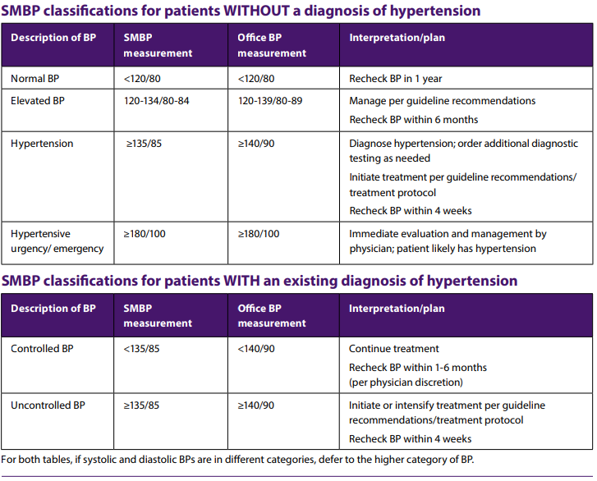

Source: MAP Hypertension - AMA-MAP | MAP Hypertension

